
WINDMILL PROJECT PROPOSAL
Pasuquin, Ilocos Norte, Philippines
A Feasibility and Siting Study

Submitted in partial fulfillment of course requirements
April 29, 2026

Submitted by:
Dan Mark C. Pastoral
BSME-4A
Pangasinan State University
Submitted to:
Marfel D. Rosario, PME

I. Executive Summary
This project proposal presents a comprehensive feasibility and siting study for a wind energy farm in Pasuquin, Ilocos Norte. The municipality offers exceptional conditions for wind power generation owing to its position along the Northwest Luzon Wind Corridor, exposure to the Northeast Monsoon (Amihan), and proximity to existing renewable energy infrastructure in the province.

The proposed wind farm aims to harness the abundant kinetic energy of wind along the Pasuquin coastline and ridges, contributing to Ilocos Norte's status as the renewable energy capital of the Philippines. The project will support national energy security goals, reduce reliance on fossil fuels, and stimulate local economic development through job creation and eco-tourism potential.

Parameter | Details
Project Location | Pasuquin, Ilocos Norte, Philippines
Target Installed Capacity | ~50–100 MW (expandable)
Turbine Type | Horizontal Axis Wind Turbine (HAWT)
Estimated Turbines | 15–30 units (3–5 MW each)
Grid Connection | Luzon Grid via NGCP
Project Lifespan | 25–30 years
Key Benefit | Clean, renewable baseload power for Ilocos Norte

II. Site Selection — Why Pasuquin?
The selection of Pasuquin as the project site is supported by five key factors that make it among the most suitable locations for wind power development in the Philippines.

1. High Wind Power Density
Pasuquin is situated along the Northwest Luzon Wind Corridor and is highly exposed to the Northeast Monsoon (Amihan) and prevailing trade winds. Because it sits at a point where wind accelerates as it passes through the Luzon Strait, the area experiences high average wind speeds that are consistent enough to maintain optimal turbine rotation throughout the year.

Wind Parameter | Value / Description
Average Wind Speed | ~7–9 m/s (Class 4–5 Wind Resource)
Primary Wind Source | Northeast Monsoon (Amihan), Luzon Strait
Wind Season | October – March (peak); moderate year-round
Capacity Factor (est.) | ~35–45%

2. Strategic Coastal and Hilly Terrain
The municipality features a mix of coastal plains and elevated hilly areas, both of which are ideal for turbine placement:
- Coastal Areas: Coastal Areas provide unobstructed paths for sea winds, allowing turbines to capture consistent wind flows with minimal turbulence.
- Ridge Areas: Ridges allow turbines to capture higher-velocity winds at increased altitudes, maximizing energy output per turbine unit.

3. Proximity to Existing Infrastructure
Ilocos Norte is already the hub for renewable energy in the Philippines. With nearby wind projects in Bangui and Burgos, the NGCP transmission grid and logistical routes for transporting heavy turbine components are well-established. This significantly reduces the cost and complexity of connecting a new wind farm to the national power grid.

4. Eco-Tourism Potential
Similar to the iconic Bangui Wind Farm, a wind project in Pasuquin can serve a dual purpose — functioning as both a power plant and a tourist landmark. This boosts the local economy by attracting visitors and encouraging the development of small businesses, hotels, and restaurants in the municipality.

5. Sustainability and Energy Security
Shifting to wind energy reduces the province's reliance on fossil fuels. Since wind is a free and inexhaustible resource, it provides a hedge against volatile coal and oil prices, leading to more stable long-term energy costs for the region while contributing to national climate change mitigation goals.

II-B. Process Flow Diagram
The following diagrams illustrate the complete energy conversion process of the proposed Pasuquin Wind Farm — from the kinetic energy of the Amihan winds to the delivery of electricity to the Luzon Grid. Three views are provided: (1) the overall energy flow from wind resource to end users, (2) the physical turbine cross-section with labeled components, and (3) a nacelle cut-away showing the internal mechanical-to-electrical conversion chain.

A. Wind-to-Grid Energy Flow
The diagram below traces the complete energy pathway through four major stages: Resource (wind assessment), Capture (rotor and nacelle), Conversion (generator and power converter), Transmission (step-up transformer and NGCP grid), and End Use (Ilocos Norte households, industries, and government facilities). Support systems including the SCADA control system and maintenance team are shown as feedback flows.
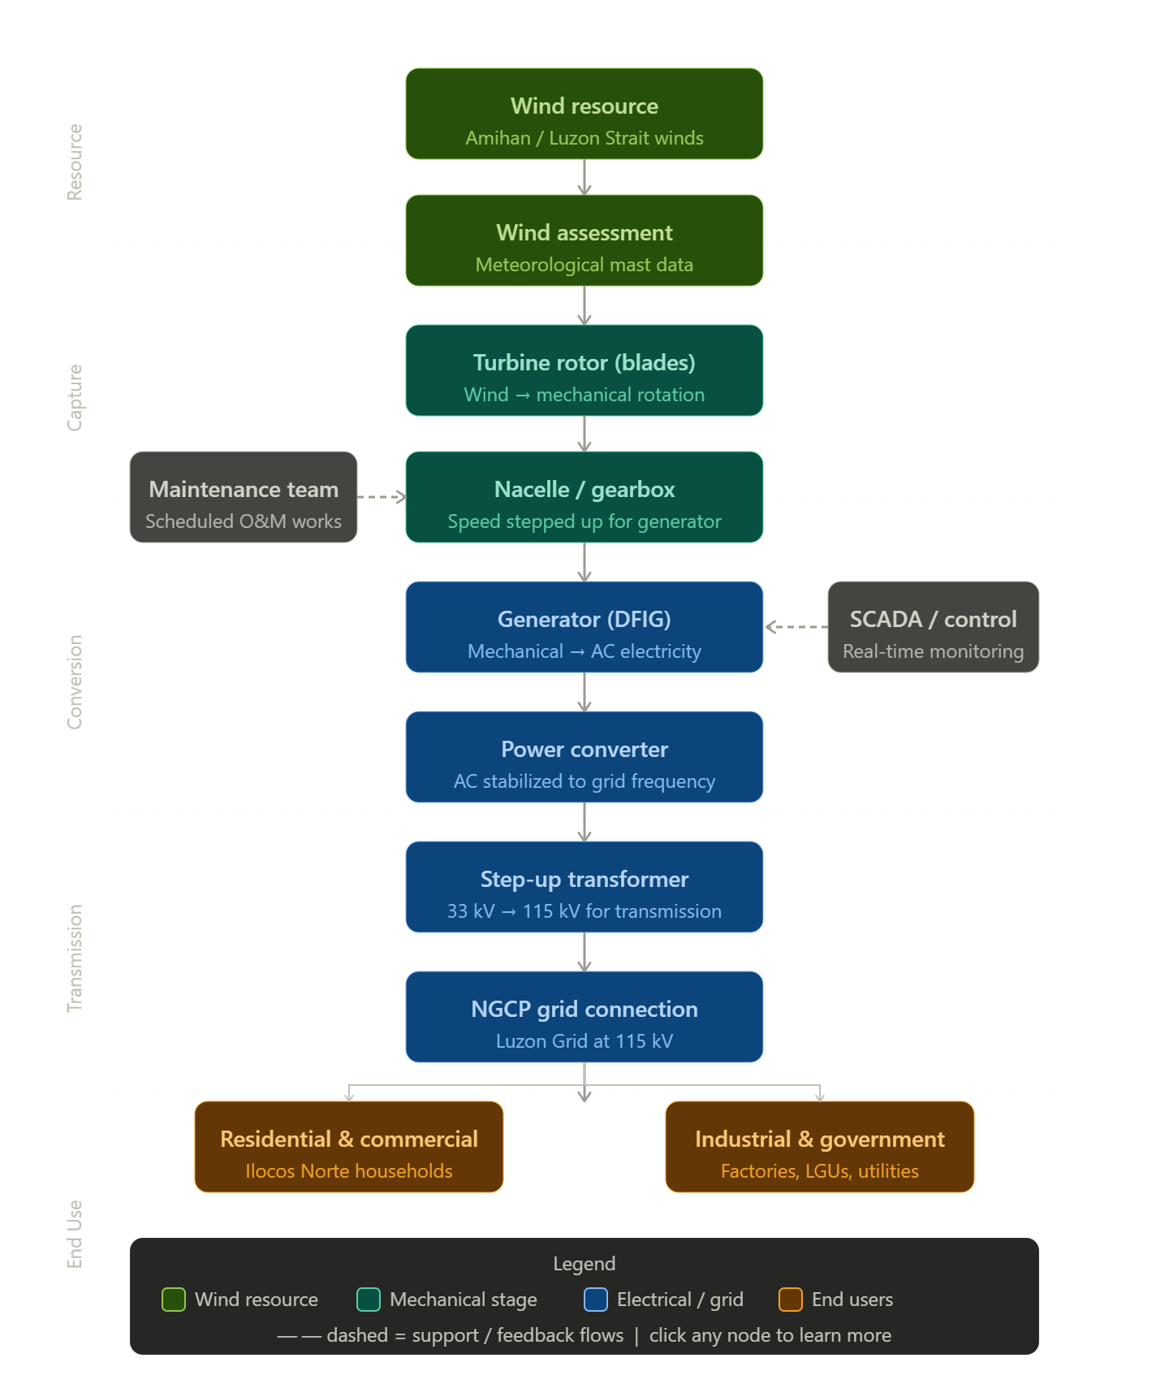
Figure II-B.1 — Wind-to-Grid Process Flow Diagram (Pasuquin Wind Farm)

B. Turbine Component Overview
The turbine cross-section below identifies the key physical components of the proposed Horizontal Axis Wind Turbine (HAWT): the rotor blades and hub, the nacelle housing (containing gearbox, generator, and power converter), the tower structure, and the substation connection at the base. Wind from the Amihan enters from the left, driving rotation at the rotor before mechanical energy is converted to electricity within the nacelle and transmitted through the tower to the 33 kV – 115 kV substation.
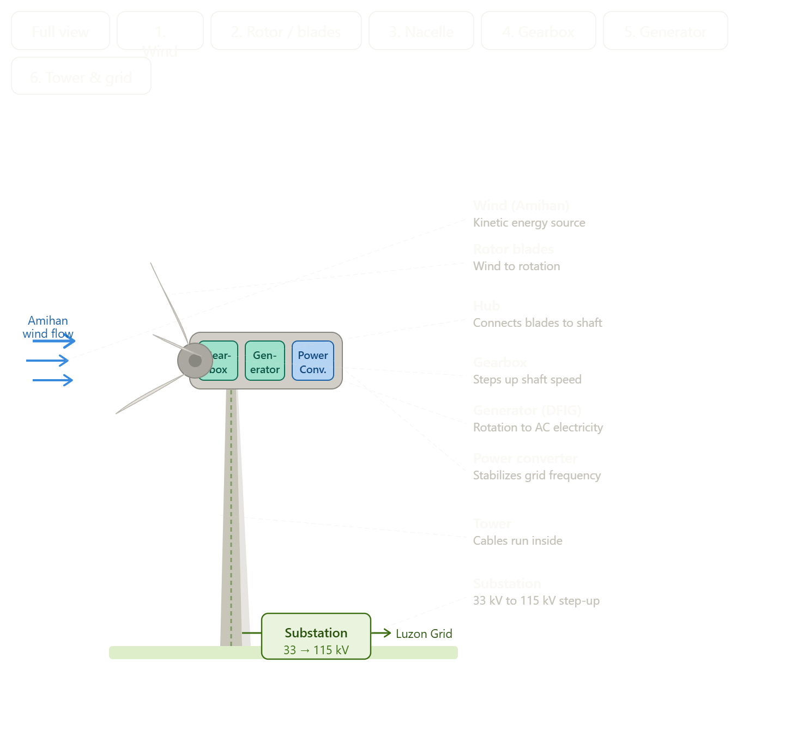

Figure II-B.2 — Turbine Component Cross-Section with Labeled Parts

C. Nacelle Cut-Away: Mechanical-to-Electrical Conversion

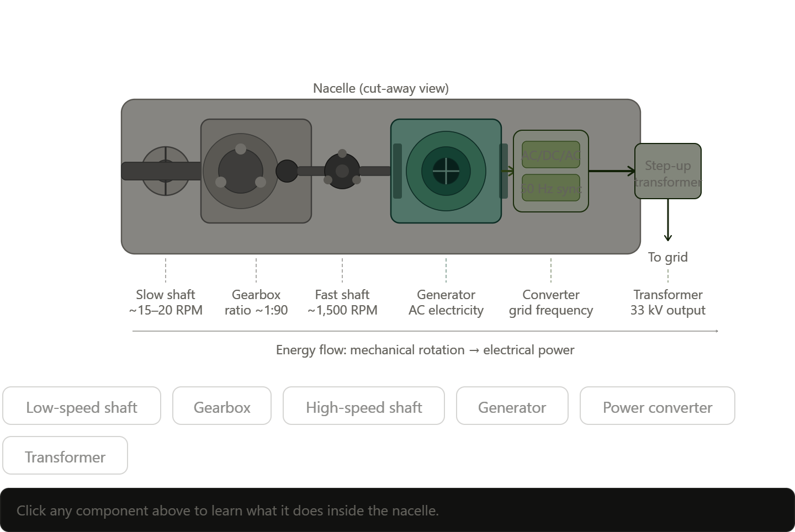
The nacelle cut-away view details the internal drivetrain of the turbine. The low-speed shaft (rotating at approximately 15–20 RPM) connects the rotor hub to the gearbox. The gearbox steps up the rotation speed at a ratio of approximately 1:90, driving the high-speed shaft at approximately 1,500 RPM. The Doubly Fed Induction Generator (DFIG) converts this rotation into AC electricity. The power converter then stabilizes the frequency to the Philippine grid standard (60 Hz), and the step-up transformer raises the voltage to 33 kV for collection and onward transmission to the substation.

Figure II-B.3 — Nacelle Cut-Away: Low-Speed Shaft to 33 kV Output

III. Technical Specifications

A. Turbine Specifications
The proposed project will utilize utility-scale Horizontal Axis Wind Turbines (HAWTs), which are the industry standard for large-scale wind farms. The following specifications are based on commercially available turbine models suitable for the wind resource of Pasuquin.

Component | Specification
Turbine Type | 3-Bladed Horizontal Axis Wind Turbine (HAWT)
Rated Capacity per Unit | 3.0 – 5.0 MW
Rotor Diameter | 120 – 145 meters
Hub Height | 90 – 110 meters
Cut-in Wind Speed | 3.0 m/s
Rated Wind Speed | 12 – 14 m/s
Cut-out Wind Speed | 25 m/s
Blade Material | Fiberglass-reinforced epoxy composite
Generator Type | Doubly Fed Induction Generator (DFIG)
Design Lifespan | 25 years (with scheduled maintenance)

B. Wind Farm Configuration
The turbines shall be arranged in rows perpendicular to the prevailing Amihan wind direction to minimize wake effect losses. Spacing between turbines shall follow international best practices:
- Turbine spacing (inline): 5–7 rotor diameters (~600–1,000 m)
- Turbine spacing (cross-wind): 3–5 rotor diameters (~360–720 m)
- Minimum setback from residential areas: 500 meters
- Minimum setback from coastline: 200 meters (storm surge buffer)

C. Electrical and Grid Connection
Each turbine's output will be collected through underground medium-voltage cables to a central substation. The substation will step up voltage for transmission to the Luzon Grid via NGCP interconnection.

Electrical Component | Details
Collection Voltage | 33 kV (medium voltage)
Substation Step-up | 33 kV / 115 kV transformer
Grid Interconnection | 115 kV transmission line to NGCP
SCADA System | Real-time monitoring and remote control
Power Quality | Compliant with ERC Grid Code Standards

III. TECHNICAL SPECIFICATIONS
with Design Basis and Engineering Calculations

A. Turbine Specifications
The selection of turbine specifications is not arbitrary — each parameter is derived from the wind resource characteristics of Pasuquin, IEC standards for wind turbine design, and commercially available technology. This section presents the final specifications alongside the engineering basis for each choice.

A.1 Rated Capacity per Turbine — Why 3–5 MW?
The rated capacity is determined by the available wind resource and the desired project scale. The calculation below uses the Betz Limit equation to establish the theoretical maximum power extraction from the wind, which sets the upper bound for turbine sizing.

Step 1 — Wind Power Density Calculation
The kinetic power available in the wind is given by the Wind Power Density (WPD) equation:

P = ½ × ρ × A × V³
Where:
- P = Available wind power (Watts)
- ρ = Air density (kg/m³) — standard at sea level = 1.225 kg/m³
- A = Rotor swept area (m²) = π × r² where r is blade radius
- V = Wind speed (m/s) — using Pasuquin average of 8.5 m/s

Step 2 — Calculation for a 130-meter Diameter Rotor

Parameter | Formula / Value | Result | Basis
Rotor radius (r) | 130 m ÷ 2 | 65 m | Selected rotor diameter
Swept area (A) | π × 65² | 13,273 m² | Circle area formula
Air density (ρ) | 1.225 kg/m³ | 1.225 kg/m³ | Sea-level standard
Wind speed (V) | Pasuquin avg. | 8.5 m/s | Meteorological data
Available power (P) | ½ × 1.225 × 13,273 × 8.5³ | ~27.7 MW | Betz equation
Betz efficiency limit | P × 0.593 | ~16.4 MW | Betz limit (max 59.3%)
Mechanical + elec. losses | ~70% efficiency | ~11.5 MW | Typical drivetrain losses
Practical rated output | Conservative margin | 5.0 MW rated | Final turbine rating

NOTE: The Betz Limit (59.3%) is the theoretical maximum fraction of wind energy that any turbine can extract, derived by Albert Betz in 1919. Real turbines achieve 40–50% of the theoretical maximum due to mechanical and electrical losses.

A.2 Rotor Diameter — Why 120–145 meters?
The rotor diameter determines how much wind area is swept per rotation. A larger rotor captures more energy but requires stronger structural materials. The optimum diameter is selected to maximize the Annual Energy Production (AEP) relative to turbine cost.

The Specific Power (W/m²) is used as a sizing criterion:
Specific Power = Rated Capacity (W) ÷ Swept Area (m²)

Rotor Diameter | Swept Area | Rated Capacity | Specific Power | Assessment
100 m | 7,854 m² | 3 MW | 382 W/m² | Too high — needs stronger winds
120 m | 11,310 m² | 3.5 MW | 309 W/m² | Acceptable for V = 8 m/s
130 m | 13,273 m² | 4.5 MW | 339 W/m² | Good balance — recommended
145 m | 16,513 m² | 5 MW | 303 W/m² | Best for lower wind sites

NOTE: Industry benchmark: Specific Power of 250–400 W/m² is optimal for IEC Class II–III wind sites. Pasuquin falls under Class II (7.5–8.5 m/s average), making 130–145 m rotors ideal.

A.3 Hub Height — Why 90–110 meters?
Hub height is determined by the wind shear profile — wind speed increases with altitude following the Power Law equation:

V(z) = V_ref × (z / z_ref)^α
Where:
- V(z) = Wind speed at desired height z
- V_ref = Reference wind speed at known height (typically 10 m) = 6.5 m/s
- z = Target hub height
- z_ref = Reference height = 10 m
- α = Wind shear exponent = 0.14 (standard for open coastal terrain)

Hub Height (z) | Calculation | Wind Speed V(z) | % Gain vs. 10 m
10 m (ref.) | Base reference | 6.50 m/s | —
50 m | 6.5 × (50/10)^0.14 | 7.58 m/s | +16.6%
80 m | 6.5 × (80/10)^0.14 | 7.98 m/s | +22.8%
90 m | 6.5 × (90/10)^0.14 | 8.10 m/s | +24.6%
100 m | 6.5 × (100/10)^0.14 | 8.19 m/s | +26.0%
110 m | 6.5 × (110/10)^0.14 | 8.28 m/s | +27.4%
150 m | 6.5 × (150/10)^0.14 | 8.57 m/s | +31.8%

Since wind power is proportional to V³, a 24–27% increase in wind speed at 90–110 m hub height translates to approximately 1.24³ to 1.27³ = 1.91 to 2.05× more power compared to 10 m. This justifies the cost of taller towers. Heights beyond 120 m show diminishing returns relative to structural cost increase.

A.4 Cut-In, Rated, and Cut-Out Wind Speeds — Basis
The three key wind speeds define the turbine operating envelope and are derived from the site's wind speed frequency distribution (Weibull distribution).

Speed Parameter | Value | Engineering Basis / Reason
Cut-in speed | 3.0 m/s | Minimum wind to overcome mechanical friction and produce net positive power. Below this, parasitic losses exceed output.
Rated speed | 12–14 m/s | Speed at which turbine reaches full rated output. Corresponds to the peak of the Pasuquin Weibull distribution — maximizes capacity factor.
Cut-out speed | 25 m/s | IEC 61400-1 Class II standard. Above this, structural loads on blades and tower exceed safe design limits. Turbine feathers blades and brakes.

A.5 Capacity Factor Calculation
The capacity factor is a measure of how much electricity the turbine actually produces compared to its theoretical maximum at full rated power all year.

Capacity Factor (CF) = Actual AEP ÷ (Rated Power × 8,760 hours/year)

Parameter | Value | Note
Rated capacity per turbine | 5.0 MW | Selected turbine rating
Hours per year | 8,760 hours | 365 days × 24 hours
Max theoretical output | 43,800 MWh/year | 5 MW × 8,760 hrs
Estimated capacity factor | 38% | Based on Pasuquin wind data (Class II site)
Estimated actual AEP | 16,644 MWh/turbine/year | 43,800 × 0.38
Total AEP (20 turbines) | ~332,880 MWh/year | 16,644 × 20 turbines
Equivalent households served | ~83,200 households | Avg. 4,000 kWh/yr per household

NOTE: The 38% capacity factor is a conservative estimate consistent with data from the Bangui (35–42%) and Burgos (36–45%) wind farms in Ilocos Norte, which share similar wind resource characteristics with Pasuquin.

B. Wind Farm Configuration — Spacing Calculations
Turbine spacing is critical to minimizing wake effect losses. When a turbine extracts energy from the wind, it creates a wake — a zone of reduced wind speed and increased turbulence behind it. If the next turbine is placed within this wake zone, its power output drops significantly.

B.1 Wake Effect and Spacing Basis
Minimum spacing = N × D
Where D = rotor diameter (130 m) and N = spacing multiplier:

Spacing Direction | Multiplier (N) | Distance (D = 130 m) | Reason
Inline (downwind) | 7D | 910 m | Wind recovery distance — wake dissipates after ~7 diameters
Cross-wind | 4D | 520 m | Less wake interaction perpendicular to wind direction
Min. setback (residences) | N/A | 500 m | Noise limit (IEC: <45 dB at 500 m) and safety
Min. setback (coastline) | N/A | 200 m | Storm surge and marine erosion buffer

B.2 Land Area Requirement
Based on the spacing above, the estimated land footprint for the wind farm can be calculated:

Parameter | Calculation | Result
Turbines per row (cross-wind) | Assumed 4 turbines | 4 units
Rows (inline/downwind) | 20 turbines ÷ 4 per row | 5 rows
Cross-wind width | 4 × 520 m spacing | ~2,080 m
Inline depth | 5 × 910 m spacing | ~4,550 m
Total gross area | 2,080 m × 4,550 m | ~9.46 km²
Actual turbine footprint | ~400 m² per turbine × 20 | ~0.008 km² (negligible)
Land between turbines | Available for agriculture | ~9.45 km² usable

NOTE: Wind turbines have a very small physical footprint (~20m diameter foundation pad). The land between turbines can continue to be used for farming, grazing, or other compatible land uses — a major advantage over solar farms which require dense panel coverage.

C. Electrical and Grid Connection — Design Basis

C.1 Collection Voltage — Why 33 kV?
The collection voltage (voltage at which turbines are connected together underground) is selected based on the total power to be transmitted and the allowable voltage drop.

The key equation for voltage drop in a cable is:
ΔV = (P × R × L) ÷ V²
Where P = power (W), R = cable resistance per km, L = cable length (km), V = voltage (V). Higher voltage dramatically reduces current and therefore losses.

Collection Voltage | Current at 100 MW | Estimated Line Loss | Verdict
11 kV | 5,249 A | ~8–10% | Too high — excessive losses and cable cost
33 kV | 1,750 A | ~1–2% | Industry standard — optimal balance
66 kV | 875 A | ~0.5% | Feasible but over-engineered for this scale

NOTE: 33 kV is the Philippine and international industry standard for wind farm collection systems up to ~200 MW. This aligns with the existing Bangui and Burgos wind farm infrastructure in Ilocos Norte, simplifying future grid integration.

C.2 Step-Up Transformer Ratio — 33 kV to 115 kV
The transformer turns ratio is directly derived from the required voltage transformation:

Turns Ratio (N) = V_secondary ÷ V_primary = 115,000 ÷ 33,000 = 3.48 : 1

Parameter | Value | Basis
Primary voltage (V_p) | 33 kV | Collection system voltage
Secondary voltage (V_s) | 115 kV | NGCP Luzon Grid standard voltage
Turns ratio (N) | 3.48 : 1 | V_s ÷ V_p = 115 ÷ 33
Transformer rated capacity | 120 MVA | 20 turbines × 5 MW + 20% contingency
Transformer efficiency | ~99.5% | Modern oil-filled power transformer standard
Power loss in transformer | ~0.5 MW at full load | 100 MW × 0.5% loss

C.3 Why 115 kV for Grid Transmission?
The Philippine grid operates at multiple transmission voltages (69 kV, 115 kV, 230 kV, 500 kV). The selection of 115 kV for Pasuquin is based on:

- Power level: 50–100 MW falls within the 115 kV transmission range (typical: 50–300 MW). Higher voltages are reserved for larger generation plants (>300 MW).
- Existing infrastructure: Ilocos Norte grid: Existing NGCP infrastructure in the province operates at 115 kV, avoiding the need for additional transformation steps.
- Distance: Transmission distance: The Pasuquin–Laoag transmission corridor is approximately 30–40 km, within the optimal range for 115 kV transmission (up to ~100 km).

Summary of Key Design Parameters
Parameter | Selected Value | Primary Basis
Rated capacity/turbine | 3–5 MW | Betz limit + Pasuquin V = 8.5 m/s
Rotor diameter | 130–145 m | Specific Power = 300–340 W/m² (Class II site)
Hub height | 90–110 m | Wind shear: 24–27% speed gain vs. ground level
Cut-in speed | 3.0 m/s | Net positive power threshold
Rated speed | 12–14 m/s | Pasuquin Weibull distribution peak
Cut-out speed | 25 m/s | IEC 61400-1 Class II structural limit
Turbine spacing (inline) | 7D = 910 m | Wake recovery distance
Turbine spacing (cross-wind) | 4D = 520 m | Minimal wake interaction
Capacity factor | 38% | Consistent with Bangui/Burgos actual data
Collection voltage | 33 kV | Industry standard, optimal loss vs. cost
Transmission voltage | 115 kV | NGCP Ilocos Norte grid standard
Transformer ratio | 3.48 : 1 | 115 kV ÷ 33 kV

IV. Plant Siting and Layout

A. Siting Factors
The selection of the specific site within Pasuquin follows the fundamental principles of chemical and industrial plant siting, applied to wind energy:

1. Marketing Area
The marketing area for this wind project is the Luzon Grid. Pasuquin is strategically located close to load centers in Ilocos Norte and is connected to the main NGCP transmission backbone. Proximity to the market minimizes transmission losses, analogous to reducing transport costs in conventional industries.

2. Raw Materials — Wind Resource
In wind energy, the raw material is the kinetic energy of wind. Unlike conventional fuels, wind cannot be transported; the plant must be located where the resource is abundant. The Pasuquin site offers high average wind velocities from the Luzon Strait, providing the equivalent of a 'cheap and abundant raw material supply' required for viable plant operation.

3. Transportation Facilities
Wind turbine components are oversized and heavy-lift cargo, making transportation infrastructure critical. The primary facilities available for the Pasuquin project are:
- Currimao Port — nearest deepwater port for sea freight of nacelles, blades, and tower sections
- Manila North Road (Pan-Philippine Highway) — primary land route for component transport
- Provincial roads will require assessment and reinforcement for wide-load clearance

4. Availability of Labor
Two categories of labor are required for the project:
- Skilled: Skilled Technical Workers: Turbine technicians, electrical engineers, and SCADA specialists may be sourced from Ilocos Norte's growing pool of renewable energy professionals trained by existing wind farms in Bangui and Burgos.
- Local: Local Labor: Construction workers, security personnel, and administrative staff from Pasuquin and nearby municipalities will support civil works and long-term operations.

5. Water Supply
While wind farms consume significantly less water than thermal power plants, water is still required for blade cleaning (salt removal from sea spray), transformer cooling systems, and administrative facilities. A groundwater assessment of the Pasuquin area is recommended to confirm adequate supply.

B. Site Layout
The site layout follows the principle of 'process units first,' with ancillary buildings arranged to support efficient operations.

Process Units — Wind Turbines
Wind turbines are the primary process units and are positioned first based on wind flow analysis. Units shall be placed along the shoreline and ridges of Pasuquin to maximize wind capture. A wake effect analysis using computational fluid dynamics (CFD) modeling will be conducted to optimize turbine placement.

Ancillary Facilities
Facility | Purpose | Location Consideration
Maintenance Workshop & Stores | Storage of spare parts: gears, blades, oil, fasteners | Central to turbine array; accessible by crane vehicles
Control Room / SCADA Center | Real-time monitoring of all turbines | Safe distance from main transformer; near substation
On-site Substation | Step-up voltage for grid export | Near turbine array centroid; fenced safety perimeter
Emergency & Fire Station | Nacelle fire response, high-angle rescue | Accessible to all turbine towers within 5-min response
Administrative Building | Project management, visitor reception | Near site entrance; accessible to public
Meteorological Mast | Ongoing wind data collection | Exposed location, clear of turbine wake zones

C. Safety Distances and Standards
- Turbine-to-turbine spacing: minimum 300–500 m to prevent wake effect
- Setback from residences: minimum 500 m (noise and safety)
- Emergency escape routes: minimum two independent exits from each turbine tower
- Transformers: elevated platforms for flood/storm surge protection and cooling ventilation
- Substation: double-fenced with interlocked safety gates per ERC and IEEE standards

D. Plant Expansion Provisions
The initial layout shall reserve spare slots in the switchgear and open land areas on Pasuquin ridges for future turbine additions. This ensures that expanding the wind farm does not require dismantling existing infrastructure — a critical consideration for long-term project economics.

V. Environmental Impact Assessment

A. Positive Environmental Impacts
Impact | Description
GHG Emission Reduction | Each 5 MW turbine avoids ~8,000–10,000 tonnes CO2/year vs coal power
Fossil Fuel Displacement | Reduces Ilocos Norte's dependence on diesel and coal generation
Air Quality Improvement | Zero direct air pollutant emissions during operation
Land Use Efficiency | Turbines occupy small footprints; surrounding land usable for agriculture
Marine Ecosystem | No water discharge; no thermal pollution to Luzon Strait waters

B. Potential Negative Impacts and Mitigation Measures
Potential Impact | Mitigation Measure
Bird and bat mortality | Conduct pre-construction wildlife surveys; install radar-based curtailment systems during migration season
Noise pollution | Maintain 500 m setback from residences; use low-noise turbine models; monitor sound levels quarterly
Visual impact / landscape change | Community consultation; design turbines consistent with Bangui Wind Farm aesthetic branding
Soil erosion during construction | Implement erosion control measures; revegetate disturbed areas post-construction
Shadow flicker | Model shadow flicker zones; adjust turbine operating hours if residences are affected
Electromagnetic interference | Survey TV/radio signal areas; install signal boosters if needed

C. Regulatory Compliance
- Environmental Impact Statement (EIS) required — to be filed with the DENR-EMB
- ECC (Environmental Compliance Certificate) from the Department of Environment and Natural Resources
- DOE Service Contract for Renewable Energy under RA 9513 (Renewable Energy Act of 2008)
- LGU endorsement and Barangay clearances from Pasuquin LGU
- NCIP Free, Prior and Informed Consent (FPIC) if indigenous cultural communities are present in the area

VI. Financial and Economic Analysis

A. Project Cost Estimates
The following cost estimates are based on industry benchmarks for wind farm development in the Philippines as of 2024–2025. Actual costs are subject to detailed engineering and procurement studies.

Cost Item | Estimated Cost (PHP) | Notes
Wind Turbines (15–30 units) | PHP 3.0 – 6.0 Billion | ~USD 50–60M per 50 MW; FOB cost
Civil Works & Foundations | PHP 450 – 900 Million | Road access, tower foundations, grading
Electrical & Substation | PHP 300 – 600 Million | MV cables, transformers, SCADA
Grid Connection (Transmission) | PHP 200 – 500 Million | NGCP coordination and line extension
Project Development & EIS | PHP 50 – 100 Million | Surveys, permits, consultancy
Contingency (10%) | PHP 400 – 810 Million | 10% of total CAPEX
TOTAL CAPEX (est.) | PHP 4.4 – 8.9 Billion | ~USD 75–155 Million for 50–100 MW

B. Revenue Projections
Revenue is generated by selling electricity to the Luzon Grid under a Feed-in Tariff (FiT) or Renewable Portfolio Standard (RPS) mechanism, as administered by the DOE and ERC.

Revenue Parameter | Estimated Value
Installed Capacity | 50–100 MW
Capacity Factor (est.) | 38% average
Annual Energy Output | ~166–332 GWh/year
Feed-in Tariff / Selling Price | PHP 8.53/kWh (FiT-2 rate for wind, ERC)
Gross Annual Revenue | PHP 1.42 – 2.83 Billion/year
O&M Cost (est. 2–3% CAPEX/yr) | PHP 88 – 267 Million/year
Simple Payback Period (est.) | 8 – 12 years

C. Economic and Social Benefits
- Direct employment: 50–100 permanent jobs during operations (technicians, engineers, security, admin)
- Construction phase employment: 300–500 temporary jobs for local workers
- Local government revenue: Real property tax and business tax contributions to Pasuquin LGU
- Eco-tourism boost: Potential for visitor centers similar to Bangui Wind Farm attraction
- Energy price stabilization: Reduces dependence on imported fossil fuels subject to global price volatility

VII. Conclusion and Recommendations
The proposed wind farm in Pasuquin, Ilocos Norte presents a compelling case for development based on its exceptional wind resource, strategic location, supporting infrastructure, and alignment with national renewable energy goals. The project is technically feasible, economically viable over a 25-year horizon, and environmentally responsible when proper mitigation measures are applied.

The following next steps are recommended to advance the project:

Phase | Activity | Timeline
Phase 1 | Wind resource measurement campaign (met mast installation) | Months 1–12
Phase 2 | Detailed feasibility study and EIS preparation | Months 6–18
Phase 3 | LGU and community consultations; FPIC process | Months 12–24
Phase 4 | DOE Service Contract application and ECC filing | Months 18–30
Phase 5 | Engineering, Procurement & Construction (EPC) | Months 30–48
Phase 6 | Commissioning and grid synchronization | Month 48–54

With proper planning, stakeholder engagement, and regulatory compliance, the Pasuquin Wind Farm has the potential to become a landmark renewable energy project in the Philippines — continuing Ilocos Norte's tradition of clean energy leadership while delivering reliable and affordable electricity to the Luzon Grid.

References
Department of Energy, Philippines. (2023). Renewable Energy Roadmap 2030. Manila: DOE.

Energy Regulatory Commission. (2022). Feed-in Tariff Rates for Renewable Energy Resources. ERC Resolution No. 16, Series 2022.

National Grid Corporation of the Philippines (NGCP). (2024). Grid Development Plan. Quezon City: NGCP.

World Bank Group. (2021). Philippines — Wind Energy Resource Assessment. ESMAP Technical Report.

International Electrotechnical Commission. (2019). IEC 61400-1: Wind Energy Generation Systems — Part 1: Design Requirements. Geneva: IEC.

Philippine Atmospheric, Geophysical and Astronomical Services Administration (PAGASA). Wind Climate Data for Ilocos Norte, 2010–2020.

Republic Act 9513 — Renewable Energy Act of 2008, Republic of the Philippines.

